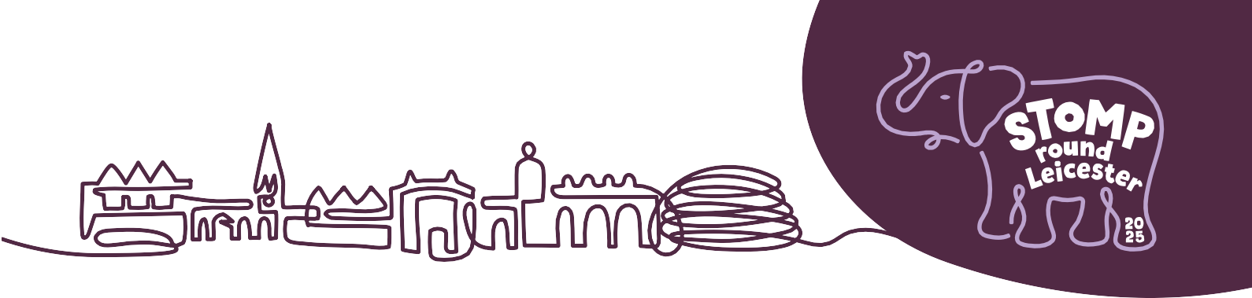

**NOTES TO EDITORS FOR PRESS RELEASES**

Please feel free to use the ‘Notes to Editors’ below in your press releases.

**NOTES TO EDITORS**

**Stomp Round Leicester**

Stomp Round Leicester is a spectacular public art event stampeding its way across the city in summer 2025. Mammoth Elephant sculptures, each one individually designed by an artist and sponsored by a business, form a free, fun, family-friendly trail of discovery for local people to explore and enjoy. At the end of the event the amazing sculptures will be auctioned to raise vital funds for LOROS Hospice (Registered Charity No 506120).

The event has been created by [Wild in Art](https://www.wildinart.co.uk/) together with [LOROS Hospice](https://www.loros.co.uk/)

stomproundleicester.co.uk | @StompRoundLeicester | #StompRoundLeicester

**ABOUT THE EVENT ORGANISERS**

**LOROS Hospice**

LOROS Hospice is a local charity which cares for more than 2,600 people across Leicester, Leicestershire and Rutland every year.

We provide free, high-quality, compassionate care and support to terminally ill adult patients, their family and carers.

Approximately one fifth of income comes from the NHS, but over £9 million still needs to be raised every year to be able to continue to provide their specialist care. To do this, the charity relies on the support and generosity of local communities and businesses in order to raise these vital funds.

loros.co.uk | @LOROSHospice | #LOROSHospice

Charity no. 506120

**About Wild in Art**

Wild in Art is the leading producer of spectacular public art events that entertain, enrich, inform and leave a lasting legacy. It brings together businesses and creative sectors with schools and local communities through the creation of uniquely painted sculptures.

Since 2008 Wild in Art has animated cities across the world including Sydney, Auckland, Cape Town and São Paulo, and created trails for the London 2012 Olympics, the 2014 Commonwealth Games, Historic Royal Palaces and Penguin Random House.

Wild in Art events have:

* Enabled over £26.5m to be raised for charitable causes
* Injected £4.3m into local creative communities
* Engaged over 1.2 million young people in learning programmes
* Helped millions of people of all ages to experience art in non-traditional settings

wildinart.co.uk | @wildinart | #wildinart

