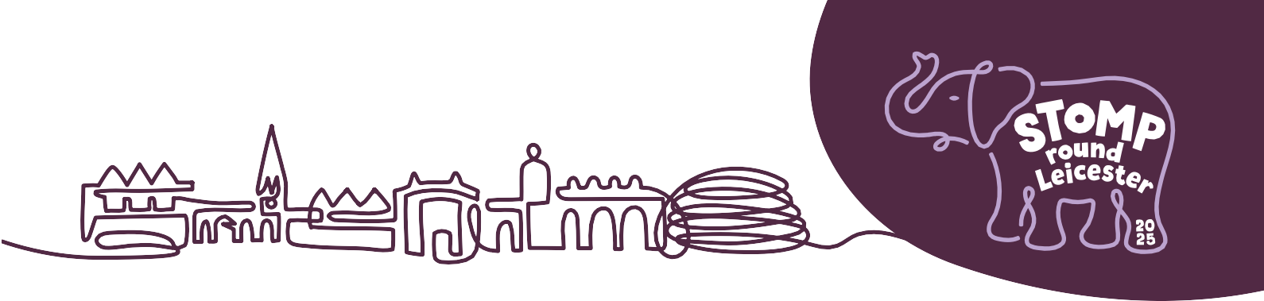

**PR AND COMMUNICATIONS COPY**

We would love you to shout about your involvement with Stomp Round Leicester, letting your staff, customers and stakeholders know you are supporting the project.

To help with this, we have created the below copy that you are welcome to use across all of your marketing activities.

**ABOUT STOMP ROUND LEICESTER WITH STATS**

Something out of this world is coming to Leicester!

[Stomp Round Leicester](https://stomproundleicester.co.uk/) is a free, fun, family-friendly art trail which will bring the people of Leicester together to share in the biggest art event the city has ever seen.

[LOROS Hospice](https://www.loros.co.uk/) is working with leading art event producers [Wild in Art](https://www.wildinart.co.uk/) to create the 10-week trail which will comprise 40 mammoth, beautifully decorated Elephants stampeding across Leicester next summer.

The trail will stampede through the city’s streets and open spaces and help even life-long Leicester dwellers discover something new about where they live.

Each Elephant will be designed by an artist and sponsored by local businesses. With a likely footfall of around 300,000 people, bringing in an expected £9 million to the local economy, Stomp Round Leicester will be a celebration of the city, its community and cultures, during LOROS Hospice’s 40th year.

At the end of the trail, each mammoth Elephant will be auctioned to raise money for LOROS Hospice to help them continue to care for over 2,500 terminally ill local people every year.

**ABOUT STOMP ROUND LEICESTER (CONDENSED WITH LINKS)**

**Stomp Round Leicester**

[Stomp Round Leicester](https://stomproundleicester.co.uk/) is a spectacular public art event that will stampede across the city in summer 2024. Mammoth Elephant sculptures, each one individually designed by an artist and sponsored by a business, form a free, fun, family-friendly trail of discovery for local people to explore and enjoy. At the end of the event the amazing sculptures will be auctioned to raise vital funds for LOROS Hospice (Registered Charity No 506120).

The event has been created by [Wild in Art](https://www.wildinart.co.uk/) together with [LOROS Hospice](https://www.loros.co.uk/)

[Stomp Round Leicester](https://stomproundleicester.co.uk/) | @StompRoundLeicester | #StompRoundLeicester

**ABOUT STOMP ROUND LEICESTER (WITH MORE EVENT DETAILS)**

**Join the herd and pack your trunk!**

A spectacular public art event that will stampede across the city for 10 weeks in summer 2024. Leicester will be brought to life by a mammoth trail of gentle giant Elephant sculptures that will form a stunning, free art trail through the city’s streets and open spaces, bringing together the community for an unforgettable event.

Each sculpture will be sponsored by a business and individually designed by an artist – either well-known or just starting out, from the local area or further afield. The trail stampedes into Leicester on Monday 14th July before packing its trunk on Sunday 21st September 2025.

After this, there will be the chance to say a final ‘goodbye’ at a Farewell Event held in the beautiful grounds of LOROS Hospice, before each Elephant is united with its forever family via our auction. All funds raised will go to help LOROS Hospice continue to care for over 2,600 terminally ill local people. This unique event is brought to you and the city of Leicester by Wild in Art and LOROS Hospice and we want you to join our herd!

There’s a way to go before the trail begins, but we hope you’ll join us for lots of ele-fun throughout summer 2025. Share the excitement and keep up-to-date with the latest news on our social media channels using #StompRoundLeicester

**APPROVED QUOTES FROM STOMP ROUND LEICESTER ORGANISERS:**

**Rob Parkinson, LOROS CEO** said: “Stomp Round Leicester will be a brilliant, colourful party and everyone’s invited! LOROS is at the heart of its community and our Elephant art trail will celebrate with everyone who supports us and uses our services. I’d like to invite the whole community to get involved and support the trail’s success.”

**Charlie Langhorne, Managing Director and Co-founder, Wild in Art** said: “Our events enable thousands of people of all ages to experience art by making it part of everyday life. The elephant is a wonderful sculpture and I have no doubt that it will capture everyone’s imagination. It’s a fantastic opportunity for businesses, artists, schools and the wider community to be part of a highly visible, collaborative and captivating project that will make everyone smile.”

**NOTES TO EDITORS**

**Stomp Round Leicester**

Stomp Round Leicester is a spectacular public art event stampeding its way across the city in summer 2025. Mammoth Elephant sculptures, each one individually designed by an artist and sponsored by a business, form a free, fun, family-friendly trail of discovery for local people to explore and enjoy. At the end of the event the amazing sculptures will be auctioned to raise vital funds for LOROS Hospice (Registered Charity No 506120).

The event has been created by [Wild in Art](https://www.wildinart.co.uk/) together with [LOROS Hospice](https://www.loros.co.uk/)

stomproundleicester.co.uk | @StompRoundLeicester | #StompRoundLeicester

**ABOUT THE EVENT ORGANISERS**

**LOROS Hospice**

LOROS Hospice is a local charity which cares for more than 2,600 people across Leicester, Leicestershire and Rutland every year.

We provide free, high-quality, compassionate care and support to terminally ill adult patients, their family and carers.

Approximately one fifth of income comes from the NHS, but over £9 million still needs to be raised every year to be able to continue to provide their specialist care. To do this, the Charity relies on the support and generosity of local communities and businesses in order to raise these vital funds.

loros.co.uk | @LOROSHospice | #LOROSHospice

Charity no. 506120

**About Wild in Art**

Wild in Art is the leading producer of spectacular public art events that entertain, enrich, inform and leave a lasting legacy. It brings together businesses and creative sectors with schools and local communities through the creation of uniquely painted sculptures.

Since 2008 Wild in Art has animated cities across the world including Sydney, Auckland, Cape Town and São Paulo, and created trails for the London 2012 Olympics, the 2014 Commonwealth Games, Historic Royal Palaces and Penguin Random House.

Wild in Art events have:

* Enabled over £26.5m to be raised for charitable causes
* Injected £4.3m into local creative communities
* Engaged over 1.2 million young people in learning programmes
* Helped millions of people of all ages to experience art in non-traditional settings

wildinart.co.uk | @wildinart | #wildinart