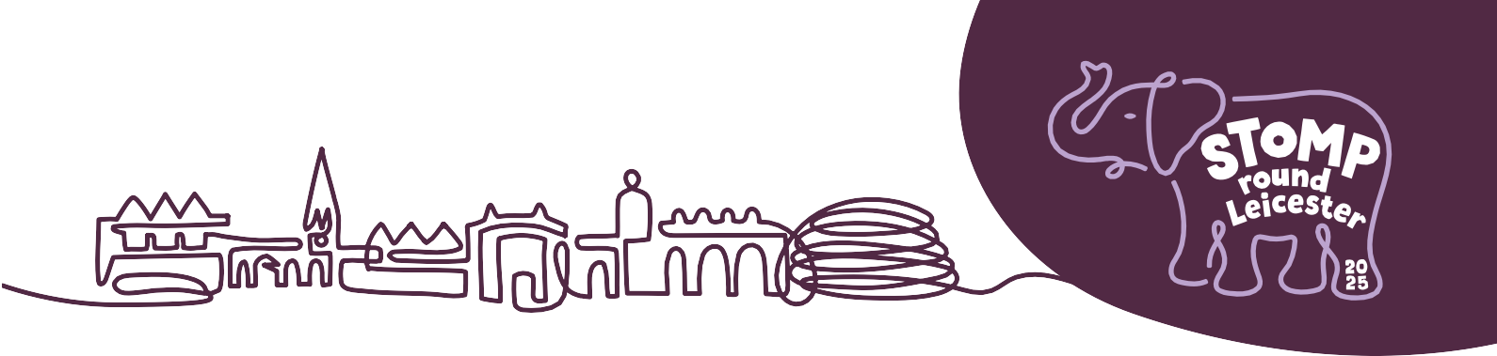

**Join the Tusk Force: Event Volunteer**

**Why we want you:**

Throughout Stomp Round Leicester, there will be several different events to accompany our herd of magnificent Elephant sculptures that will be stampeding into the city this summer as part of a spectacular public art trail raising vital funds for LOROS Hospice.

As a volunteer, you become an essential part of the event. Not only does your contribution help the event run smoothly, by giving us your time, we can concentrate on raising money to ensure the best possible care for our patients.

**What you will be doing:**

Event volunteers could be doing any of the following:

* Helping with set up and pack down of events
* Manning a stall e.g. hook a duck, spin the wheel, lucky dip
* Car park management
* Crowd control/ marshalling
* Assisting on an admin desk
* Selling merchandise, raffle tickets etc.

**The skills you need:**

* Friendly and outgoing personality
* Good communicator, confident talking to and engaging with people
* Ability to represent the charity positively
* Can-do attitude

**What’s in it for you:**

* Opens the door to new friendships
* A chance to be part of your local community
* Chance to learn a new skill or experience
* Get to share experiences with people from backgrounds and cultures you may never have had the chance to before
* Increase your confidence and self esteem
* Create lasting memories

**Opportunities available:**

* LOROS Twilight Walk, 26th July, King Power Stadium
* The Elephants Big Day Out - Farewell Weekend, 4th and 5th October, LOROS Hospice, LE3 9QE